**BCDE102 Assessment 3 Daniel Wild**

**Iteration 1**

**WHERE:**

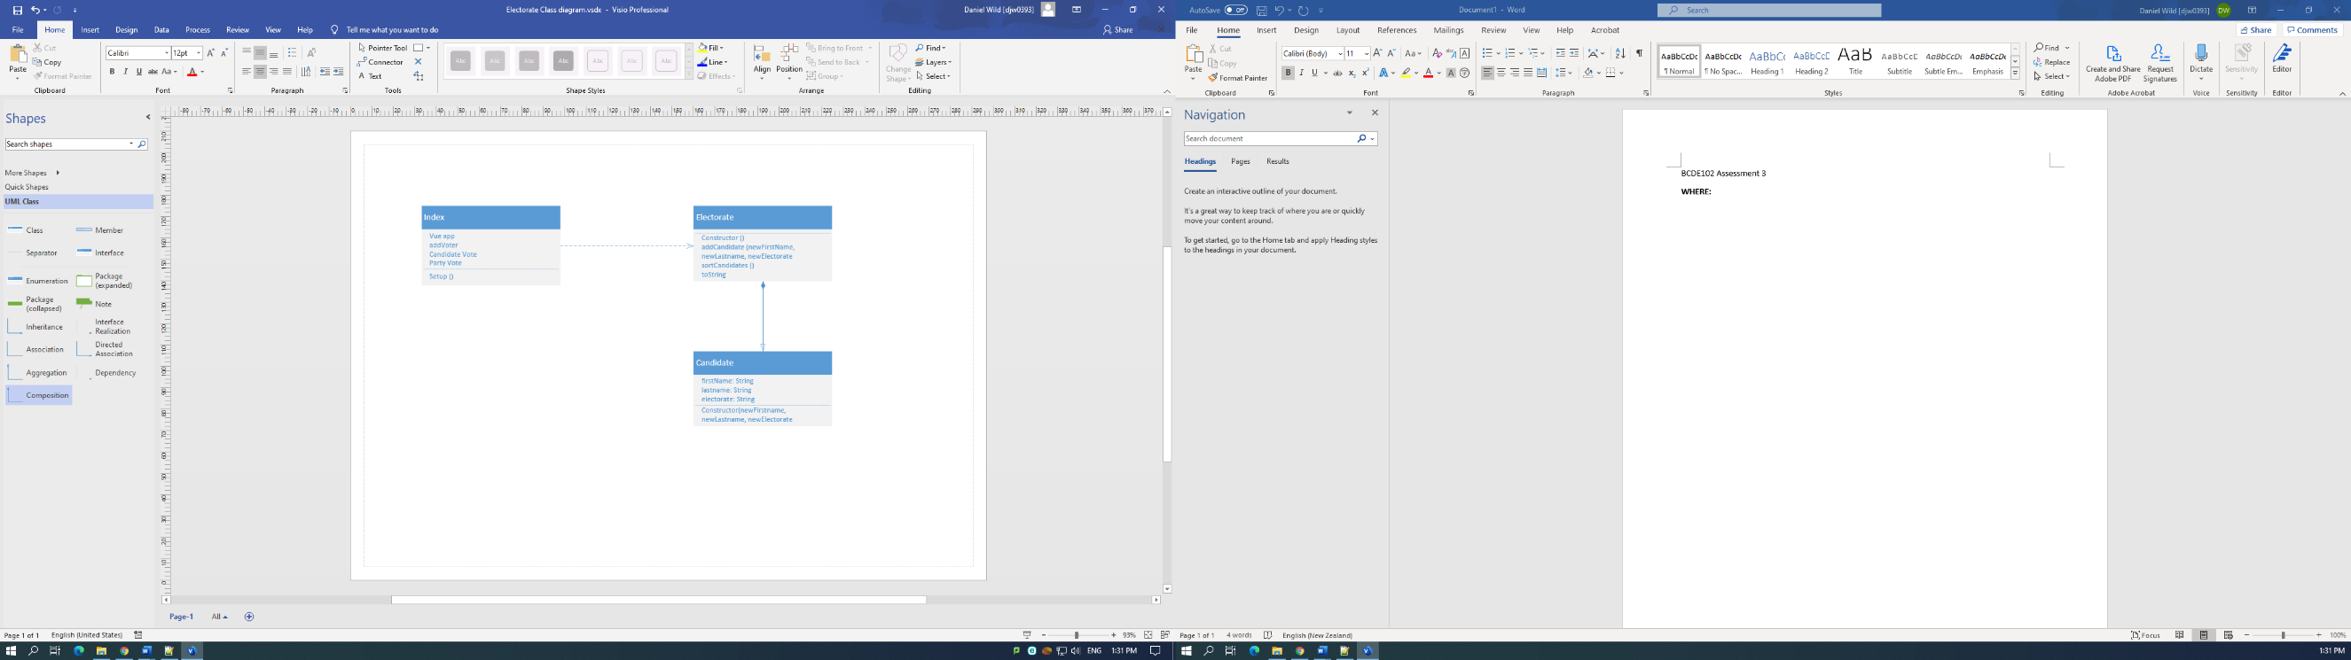**WHAT:**

The goal of iteration one is too add the names and parties of the candidates and the Party list onto the page using Vue.

Users Story:

I am a voter from Wairarapa I want to be able to see the candidates and parties I can vote for.

The Tasks:

1. Create a plan of how we will write the program
2. Analyse the Box of Toys example to get a template of the JS and Vue
3. Recreate Box of Toys using the code from the Election 2017 with the updated 2020 data
4. Run Jasmine tests to show the data is entered correctly

Task Time Estimates

* Create a plan by analysing Box of Toys – 20 minutes
* Update Election data from the 2020 Election Wikipedia – 10 minutes
* Edit Box of toys with the code from Election 2017 – 30 minutes
* Create Jasmine unit tests – 30 minutes

Estimated Total Time: 1 hour 30 minutes

Planned product is a voter would be able to see the names of both the candidates and the parties in the form and have radio buttons to be able to select one that they want to vote for.

Task Times

* Create a plan – 30 minutes
* Edit Box of Toys – 30 minutes
* Update the Vue in Index – 15 minutes
* Get updated Election data – 20 minutes
* Create unit tests – 30 minutes

Total Time: 2 hours 5 minutes

**How:**

Unit tests

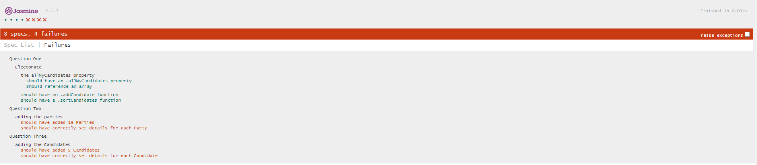

Unit tests one tests if Electorate has the right properties.

Two and three tests to make sure controller have the right number of candidates and parties. (These fail at the moment as controller is not working so the data is hard coded into Index. This will be fixed in iteration 2)

**Evaluation:**

Style

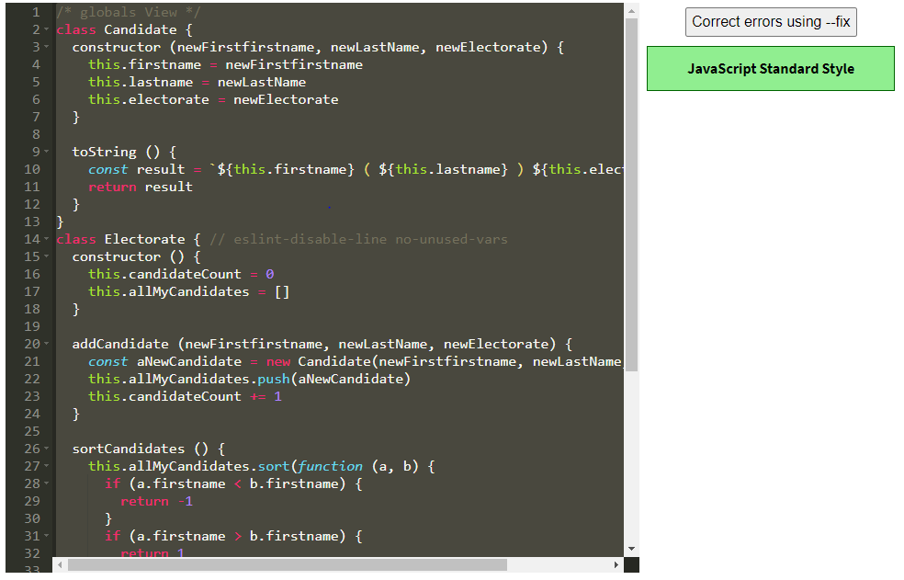

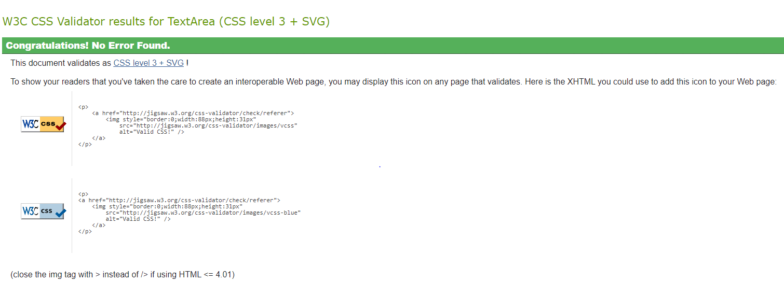

**What happened vs what was planned:**

My plan to use the complete Election 2017 from BE101 proved too complex to edit for iteration 1 it was better to rework box of toys Vue. I will add back in parts of Election 2017 in the next versions as needed.

**Performance Review:**

I was able to achieve my iteration 1 goal of have the candidates and parties on the screen with radio buttons next to them and vote buttons. I was not able to code them in with controller like I wanted and the boxes, button to sign in and vote buttons don’t do anything at the moment but that will be added in other versions. What I would do different next time is I would focus more on getting the JS to work the way I wanted rather than the way the Vue and CCS look for version 2.